Set up a VPC with an Internet gateway

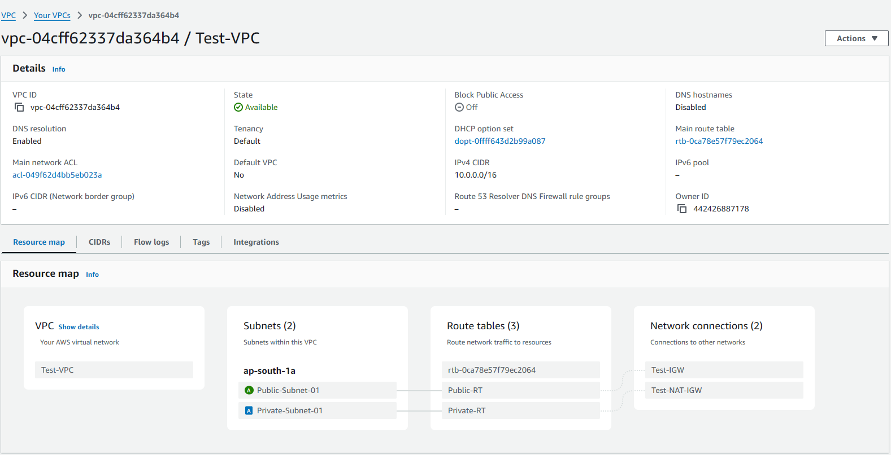

create a public subnet with 256 IP addresses

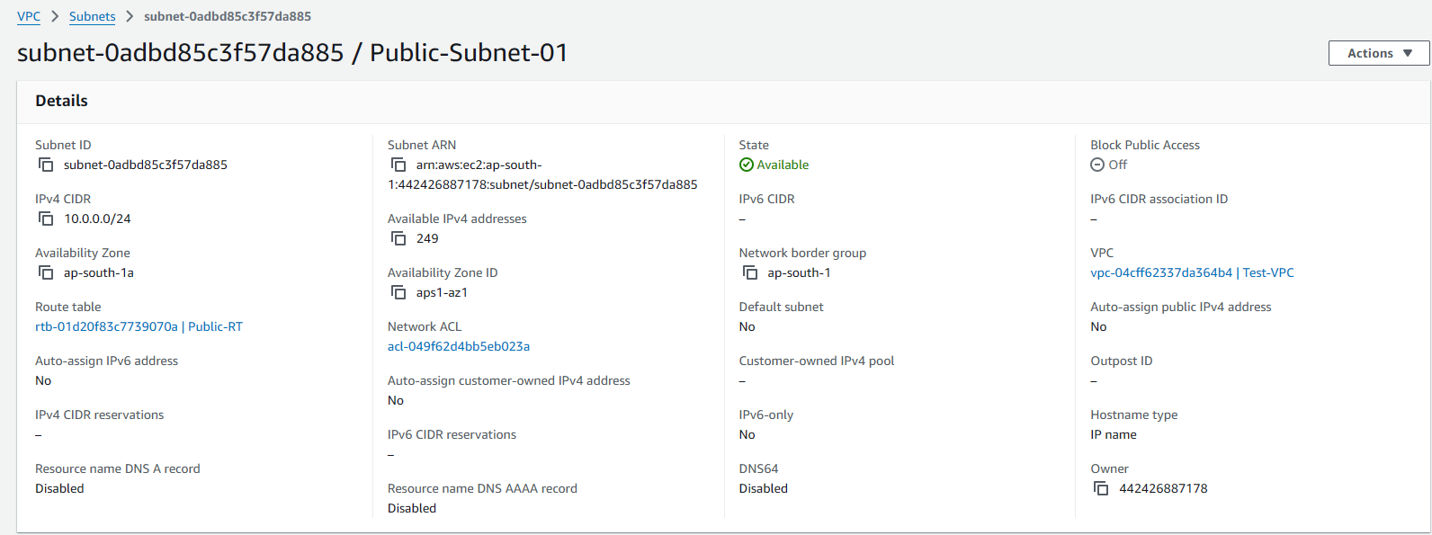

a private subnet with 256 IP addresses

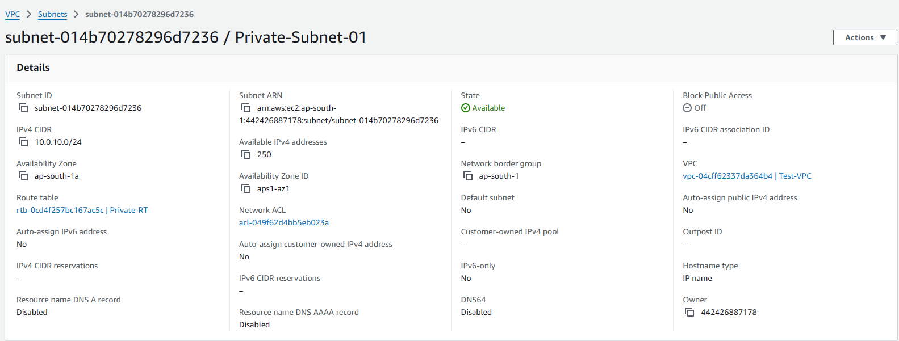

make a route table connecting the Internet gateway and the subnets

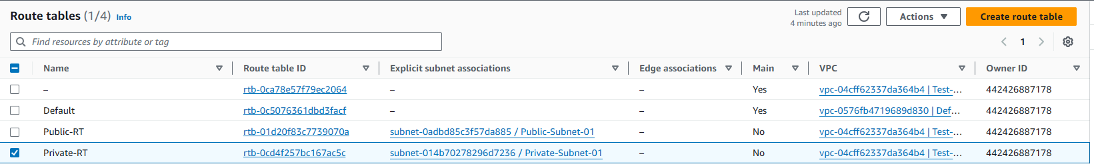

and launch a Linux EC2 instance by using the above VPC and public subnet.

